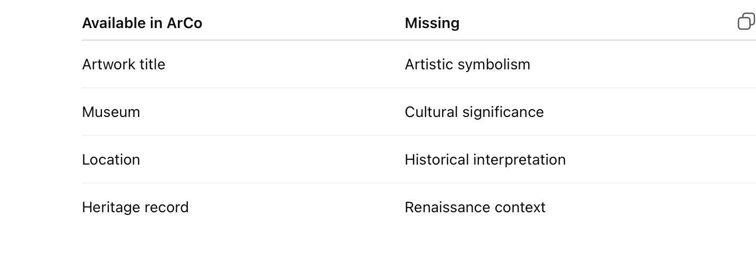

Available in ArCo | Missing
Artwork title | Artistic symbolism
Museum | Cultural significance
Location | Historical interpretation
Heritage record | Renaissance context
Сделай скриншот таблицы.
Подпись:
Figure 4. Comparison of available and missing information identified in ArCo.

